Instructions for formatting Workshop proposals (HEADING 1: Arial 20pt)
Authors’ names, separated by comma – leave blank for anonymous submission
contact.author@email.mail
Organisation
Venue address and travel directions for Embedded Workshops
Full contact address

Workshop outline (HEADING 2: Arial 14pt)

We demonstrate how to use this template for submission of Workshop proposals to the ServDes.2020 conference. Please use the formatting styles as instructed.

Your workshop summary should be no longer than 150 words (Normal Style: Garamond 11pt). Please write in a lively and inviting manner and supply compelling imagery that will attract participation. In your proposal, please submit a range of images (no more than 1mb each ) to the innovative, haptic, tactile, performative nature of the workshops.

KEYWORDS in upper case (KEYWORDS Arial 10pt): formatting instruction, template, full papers

Layout Style: (Normal Style)
Sample text:
- Bullet points (List Paragraph)
- Bullet points (List Paragraph)
- Bullet points (List Paragraph)

The page is A4 (21cm x 29.7cm) and set with a top margin of 2 cm, a bottom margin of 2.5 cm, a left margin of 3.5 cm, and a right margin of 3.5 cm.
Footers and headers should not be used for paper specific text. Never use headings directly under headings, always add text below headings.

Your workshop description should be approximately 6-800 words using the headings (Normal Style: Garamond 11pt). Once text and images are formatted

Title and Authors
Multiple row titles should only run over two rows.
In the anonymous submission, leave the placeholders for Authors and affiliation as they appear in this template. When preparing your final submission, all authors should be listed in the author’s row. The primary author should be the contact author and fill out contact details.

Language and style
The written language of the conference is English. Try using gender neutral language as much as possible and make sure to explain any culturally specific formulations and be aware not to use ambiguous terms or saying that may be unknown if you are not a native English speaker. Also try to use a simple and clear style of reasoning and avoid difficult technical terms. Show the full name before you use acronyms the first time.

Images

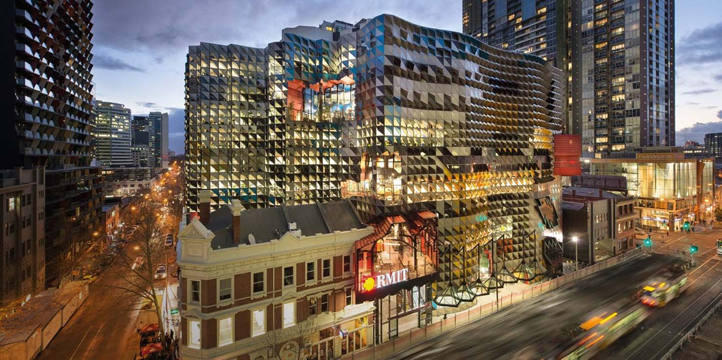

Caption for figures and credits: (Heading 4, Arial 10pt)

Images and figures can take up the entire column, in full colour, but not exceed the column width. Please select top and bottom for formatting. Please make sure the images you insert do not exceed 1Mb each (NB: pdf maximum size is 5MB so please re-size and select carefully so they do not exceed upload limit).

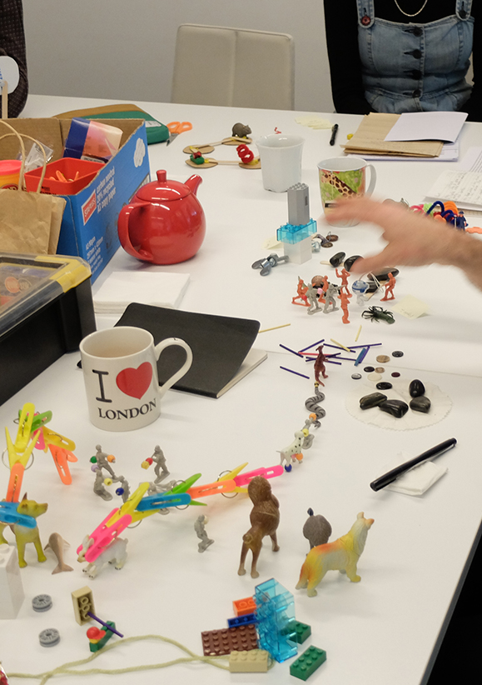

Caption for figures and credits: (Heading 4, Arial 10pt)

Please note that ServDes. Conference submission system only accepts uploads in a PDF format (maximum file size: 5MB). Still images may be embedded in the pdf. Other types or larger-sized media should be made available online, the URL of which must be included and clearly indicated in your pdf submission. Please make sure that copyright is sought prior to submission, if the images are not your own. If the submission contains images of people, please obtain permission by those to make them public.

References and citations
Citations as part of a sentence shows authors names in text and year within parenthesis: e.g. as stated by Holmlid & Evenson (2007). Citations that are not part of a sentence should be placed inside parenthesis alphabetically: e.g. revealing patterns of human thought (Bechmann, 2010; Holmlid & Evenson, 2007; Howard, 2008) or other phenomena (Participle, 2008). If a reference is authored by one or two individuals, give both names. For three or more authors, name only the first one followed by et al.. Try using only sources you have personally read or make sure it is clear that you are referring to a second hand source.

Quotations should be part of the normal text flow and include page numbers when possible; e.g. “… a crucial dimension to use to increase understanding and the role of prototyping is at what stage in the generic service design process a prototyping method is used.” (Holmlid & Evenson, 2007, p. 6). For quotations longer than three rows (or longer than 40 words), they should be indented in a paragraph of their own and use italics style (QUOTE: Garamond 11pt italics):
Beveridge was a 20TH century giant. The vision and strategy he set out in his first 1942 report were supported by political thinkers on the left and right, and by the general public who wanted a new and fairer Britain. Before Beveridge, Britain can be seen as a place of gross inequality, with health care that few could afford or find, schools which looked like those portrayed in a Dickens’ novel, and a society desperately hanging on to its colonial legacy. The post-war welfare state swept all this away in one of the most dramatic social transformations Britain has ever seen. (Participle, 2008, p. 2)
References should be formatted like in the examples below. If the sources are in another language than English, please provide an English translation of the title and source.

References (HEADING 2)
Example of references: please use the APA style for referencing. Note that for the review no references to submitting workshop coordinators should be included.

Book with one author:
King, M. (2000). Wrestling with the angel: A life of Janet Frame. Auckland, New Zealand: Viking.

Conference paper online:
Bochner, S. (1996, November). Mentoring in higher education: Issues to be addressed in developing a mentoring program. Paper presented at the Australian Association for Research in Education Conference, Singapore. Retrieved from http://www.aare.edu.au/96pap/bochs96018.txt

Journal article:
Germann, F., Ebbes, P., & Grewal, R. (2015). The chief marketing officer matters! Journal of Marketing, 79(3), 1-22.

